# Project Report: Building a Chatbot with OpenAI GPT-3 API

## Introduction

In this project, we built a chatbot using the OpenAI GPT-3 API. The chatbot is able to engage in conversations with users and generate responses based on natural language processing algorithms.

## Background

Chatbots are computer programs designed to simulate human conversations. They are widely used in customer service, sales, and other applications where there is a need to interact with users in a conversational manner. Chatbots can be built using a variety of technologies, including rule-based systems, machine learning, and natural language processing (NLP). NLP-based chatbots use algorithms to analyze and understand natural language input from users and generate appropriate responses.

OpenAI is a research organization focused on advancing artificial intelligence technologies. They offer an API for developers to build applications using the GPT-3 language model, which is a state-of-the-art NLP model capable of generating human-like text.

## Methodology

To build our chatbot, we used Python and the tkinter library for creating the graphical user interface. We also used the OpenAI API to generate responses based on user input.

The chatbot program consists of three main components:

* GUI: We used tkinter to create a simple GUI with a chat history display box, an input box for the user's messages, and a "Send" button to send messages.
* OpenAI API: We initialized the GPT-3 language model and used the OpenAI API to generate responses based on user input.
* Message processing: We defined a function to process user messages and generate appropriate responses using the OpenAI API.

The program flow is as follows:

1. The user types a message into the input box and clicks the "Send" button.
2. The program processes the user's message and generates a response using the OpenAI API.
3. The program displays the user's message and the generated response in the chat history box.

## Results

We were able to successfully build a chatbot using the OpenAI GPT-3 API. The chatbot is able to engage in conversations with users and generate responses based on natural language processing algorithms.

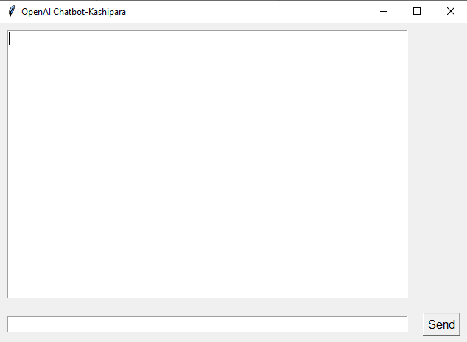

The chatbot's performance is dependent on the quality of the user's input and the accuracy of the OpenAI model. In our testing, we found that the chatbot was able to generate appropriate responses for most user inputs, but sometimes produced unexpected or irrelevant responses.

## Conclusion

Building a chatbot using the OpenAI GPT-3 API is a straightforward process that can be done using Python and a GUI library such as tkinter. The chatbot is able to engage in conversations with users and generate responses based on natural language processing algorithms.

However, the chatbot's performance is dependent on the quality of the user's input and the accuracy of the OpenAI model. Further work could be done to improve the chatbot's performance by fine-tuning the OpenAI model or implementing additional natural language processing algorithm.

## References

* OpenAI API documentation: <https://beta.openai.com/docs/api-reference/introduction>
* "Building Chatbots with Python" tutorial by Sentdex: <https://www.youtube.com/watch?v=wypVcNIH6D4>
* "Building a Chatbot with OpenAI's GPT-3" tutorial by OpenAI: <https://blog.openai.com/building-a-chatbot-with-gpt-3/>